**Creating Microservices for account and loan**

**Account Microservice**

AccountControllerpackage com.cognizant.account;

import org.springframework.web.bind.annotation.*;

@RestController

@RequestMapping("/accounts")

public class AccountController {

@GetMapping("/{number}")

public Account getAccount(@PathVariable String number) {

return new Account(number, "savings", 234343);

}

}

class Account {

private String number;

private String type;

private double balance;

public Account(String number, String type, double balance) {

this.number = number;

this.type = type;

this.balance = balance;

}

public String getNumber() {

return number;

}

public String getType() {

return type;

}

public double getBalance() {

return balance;

}

}

OUTPUT :

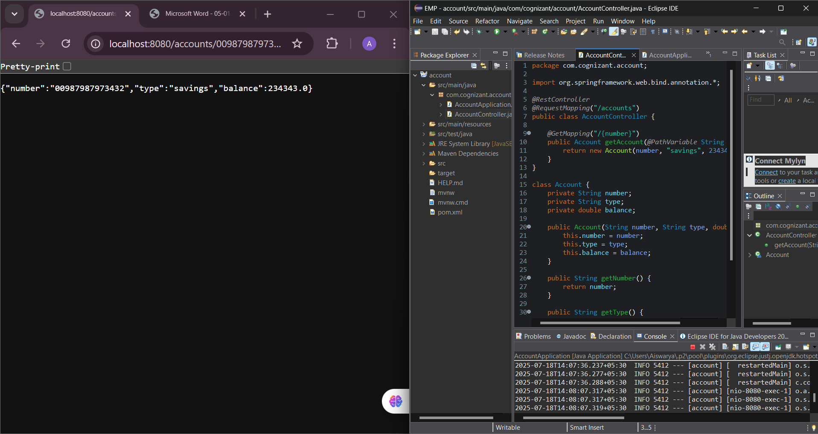

{

"number": "00987987973432",

"type": "savings",

"balance": 234343

}

**Loan Microservice**

**LoanController**

package com.cognizant.loan;

import org.springframework.web.bind.annotation.*;

@RestController

@RequestMapping("/loans")

public class LoanController {

@GetMapping("/{number}")

public Loan getLoan(@PathVariable String number) {

return new Loan(number, "car", 400000, 3258, 18);

}

}

class Loan {

private String number;

private String type;

private double loan;

private double emi;

private int tenure;

public Loan(String number, String type, double loan, double emi, int tenure) {

this.number = number;

this.type = type;

this.loan = loan;

this.emi = emi;

this.tenure = tenure;

}

public String getNumber() {

return number;

}

public String getType() {

return type;

}

public double getLoan() {

return loan;

}

public double getEmi() {

return emi;

}

public int getTenure() {

return tenure;

}

} **OUTPUT :**

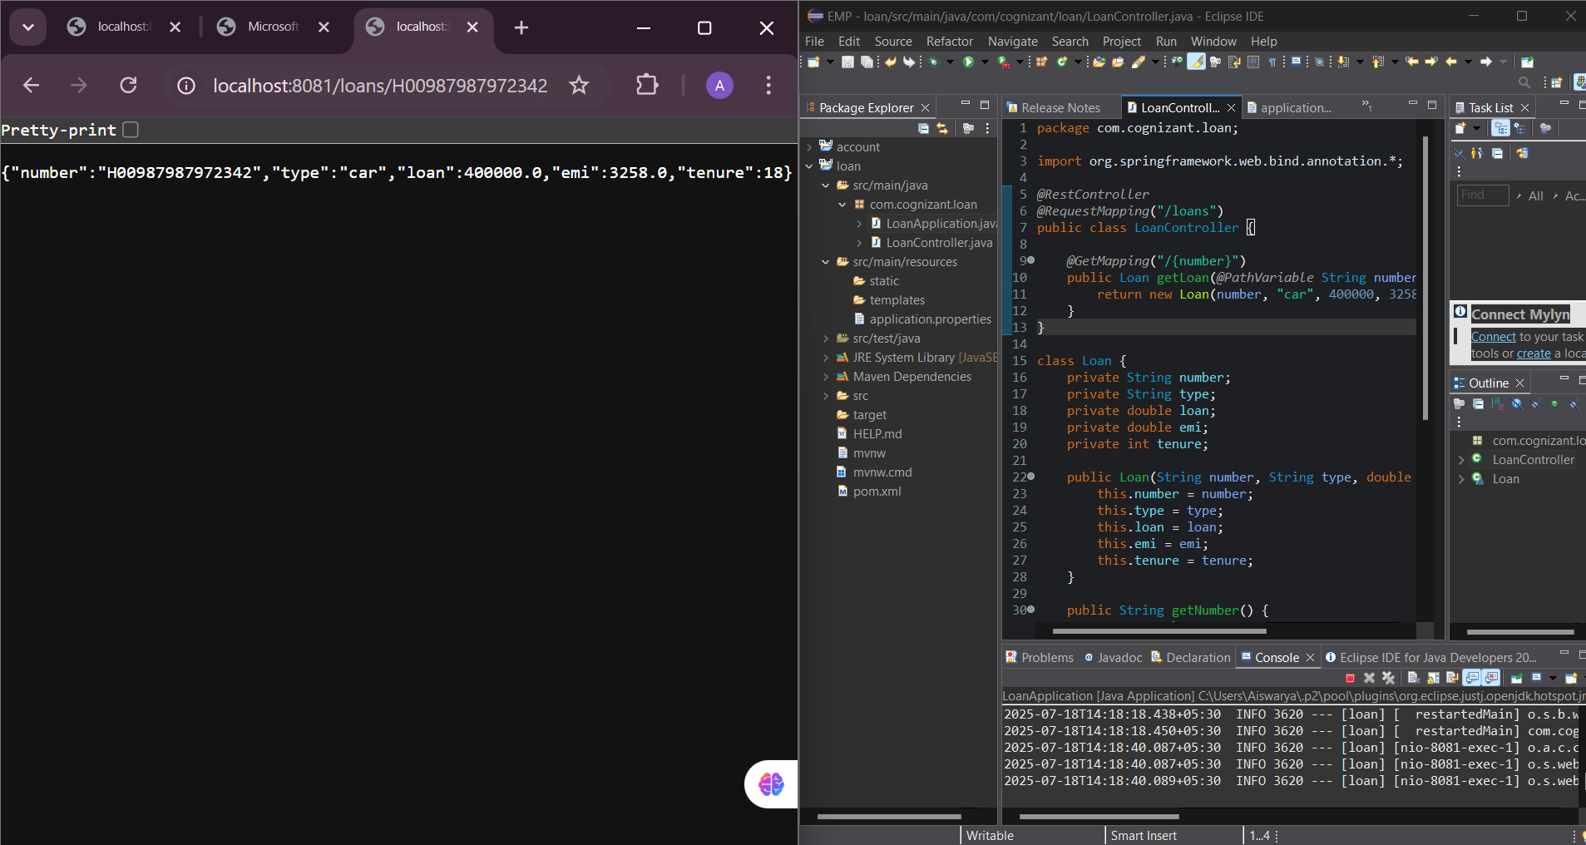

{

"number": "H00987987972342",

"type": "car",

"loan": 400000,

"emi": 3258,

"tenure": 18

}